Received 00th January 20xx,

aGuangdong Key Laboratory for Research and Development of Natural Drugs, Key Laboratory of Research and Development of New Medical Materials of Guangdong Medical University, School of Pharmacy, Guangdong Medical University, Dongguan, 523808, P. R. China.

bSchool of Chemistry and Chemical Engineering, Nantong University, Nantong 226007, PR China

cDepartment of Chemistry, Faculty of Science, University of Lucknow, Lucknow 226 007, India.

E-mail: chyshi@ntu.edu.cn, [abhinavmarshal@gmail.com](mailto:abhinavmarshal@gmail.com) and [jianqiangliu8@gdmu.edu.cn](mailto:jianqiangliu8@gdmu.edu.cn)

#The authors have the equal contribution on this work.

Electronic Supplementary Information (ESI) available: See DOI: 10.1039/x0xx00000x

Accepted 00th January 20xx

DOI: 10.1039/x0xx00000x

www.rsc.org/

A new Zn(II)-based 3D metal–organic framework with uncommon *sev* topology and its photocatalytic property for the degradation of organic dyes

Ying Pan,#a Qiongjie Ding,#a Hongjia Xua, Chunyue Shi*b Amita Singhc, Abhinav Kumar*c and Jianqiang Liu*a

A new d10-configuration based Zn(II) 3D metal–organic framework (MOF) with formula of {[Zn4(NDC)3.5(*μ*4-OH)(DMF)]·1.7DMF}n (**1**) has been synthesized using 1,4-naphthalenedicarboxylic acid (H­2NDC­) ligand and characterized. The single crystal X-ray diffraction results inidcate that in the newly synthesized MOF, a 7-connected [Zn4(*μ*4−OH)(COO)7] clusters are formed which are extended by NDC2- ligands to generate an uncommon ***sev*** topology. The photocatalytic properties of **1** to photodegrade model organic dyes *viz.* methyl violet (MV) and rhodamine B (Rh B) have been systematically investigated. The photocatalysis results demonstrated that **1** shows promising photocatalytic degradation activity against these organic dyes. The possible photocatalytic mechanism through which **1** displayed photocatalytic properties to photodegrade organic dyes has also been proposed with the aid of density of states (DOS) calculations.

Introduction

Over the past two decades, significant progress had been witnessed in the chemistry related to the development of porous materials especially the hybrid organic/inorganic porous materials well known as metal–organic frameworks (MOFs) which offer multifarious research as well as the real-world applications.1-3 The safe and efficient degradation of organic aromatic pollutants from waste-water is now becoming a challenging topic due to its ecological and environmental importance.1a At present, the industrial waste-water treatment technologies are typically handled by adsorbing and/or coagulating out the pollutants from waste-water. However, these treatment techniques are incapable of eliminating and converting the organic waste especially aromatic dyes to biodegradable form. Other water treatment methods employ chemical and membrane materials which although are efficient but involve high costs, and additionally sometimes generate toxic secondary pollutants.1-3 It had been reported that metal-organic frameworks (MOFs) which possesses high porosity, exhibit semiconducting behavior upon light irradiation and hence these systems may be used as potential photocatalysts. Therefore, in view of their semiconducting nature they can emerge as promising candidates for waste water treatment. Further, their catalytic properties can be exploited for the green conversion of toxic organic compounds to useful organic derivatives. The MOF-5 was the first metal-organic framework which was proposed to behave as a photocatalyst.This MOF comprises of Zn4O clusters located at the corners of a cubic framework and connected orthogonally by 1,4-bdc ligands.4 Therefore, the precise designing and fabrication of MOFs can offer improved photocatalytic properties which is vital for the safe and sustainable degradation of organic dyes under light irradiation. An effective strategy to construct desired MOFs-based photocatalyst is the judicious selection of organic ligands.As the proper choice of the ligand can not only tune the topology of the resulting MOF but also is capable of altering the electronic and in turn the catalytic properties of such materials.5

Keeping in mind the above-mentioned aspects and in an attempt to investigate semiconducting properties and band structures of MOFs,6-7 we have chosen 1,4-naphthalenedicarboxylic acid (H2NDC) as a ligand to construct a new MOF. The selection of this ligand to develop effective building block stems from the following facts: (1) it possess many potential coordination modes thereby paving a pathway for the construction of a topologically diverse family of materials (Scheme S1);8-10 (2) the H2NDC would be more effective in constructing the high-dimensional framework; (3) the fused naphthalene system  is equal to the sterically bulky substituent, which can influence interpenetration occurrence. Also, the NDC ligand is conjugated polycarboxylic acid that can bind several metal centers with specific coordination geometry to construct polynuclear clusters, *viz.* Zn2, Zn3, Zn4, Zn5, Zn6, Zn7, Zn8, Mg6, Co8 and Co5, *etc*. (Table 1).10 However, to obtain desired MOFs having intriguing topological structures with potential applications, much effort has been devoted to construct odd-connected network but despite substantial efforts only limited number of odd-connected MOFs are known.10j

In continuance to our program to develop MOFs that can offer semiconducting as well as photocatalytic properties,11-12 a new Zn(II) based 3D MOF {[Zn4(NDC)3.5(μ4-OH)(DMF)]•1.7DMF}n (**1**) has been successfully synthesized using 1,4-naphthalenedicarboxylic acid (H2NDC) as the organic linker. **1** offered good photocatalytic activity for the green degradation of organic dyes under UV light irradiation. The pertinent results of these investigations are presented herein.

**Table 1**Performances of some MOFs constructed with d-block metals and H2NDC ligand.

|  |  |  |  |  |  |
| --- | --- | --- | --- | --- | --- |
| MOF | SBU | Bridging modes | Topology | Application | Ref. |
| [Zn2(4-pzpt)2(ndc)]n | z-sr.jpg | μ4-η1:η1 η1:η1 | 3D (4.64.7)2(64.72) | detecting anions | 10a |
| MOF-5 | MOF5.jpg | μ4-η1:η1 η1:η1 | 3D | adsorption gas | 10b |
| {[Zn8(μ4-O)2(ndc)6(DMF)3] | 1.jpg | μ4-η1:η1 η1:η1 | 3D (412.63) | luminescence materials | 10c |
| [cation][Zn7(μ4-O)2(ndc)6] | 2.jpg | μ4-η1:η1 η1:η1 and μ3-η1:η1 η1:η0 | 3D (424.64) | luminescence materials | 10d |
| [Zn5(btz)6(ndc)2(H2O)] | 5.jpg | μ2-η1:η0 η1:η0 | 3D **mdf** topology | detecting metal ions and solvents | 10e |
| [Zn5(μ3-OH)2(ndc)4(bix)2] | 6.jpg | μ4-η1:η1 η1:η1 | 3D (36.43.4  .53.62) | luminescence materials | 10f |
| [cation][Zn7(μ4-O)2(ndc)6] | 7.jpg | μ4-η1:η1 η1:η1 | 3D **bcu** topology | detecting solvents | 10g |
| [Zn2(H2O)(ndc)2(tpcb)] | 8.jpg | μ2-η1:η0 η1:η0 | 3D (10·122)·(102.12) | photocatalytic application | 10h |
| [cation][Mg6(ndc)5(Hndc)2(HCOO)2] | 9.jpg | μ4-η1:η1 η1:η1 , μ3-η1:η1η1:η0, μ4-η1:η1 η1:η1 and μ4-η1:η2 η1:η1 | 3D **bct** topology | adsorption gas | 10i |
| [Co8(μ3−OH)4(ndc)6(btp)(H2O)6] | 10.jpg | μ4-η1:η1 η1:η1 , and μ5-η1:η2 η1:η1 | 3D (420  .68) | magnetism | 10j |
| [Co4(μ2-H2O)2(ndc)4(dpp)2] | 11.jpg | μ4-η1:η1 η1:η1 and μ3-η1:η1 η1:η0 | 3D (36.434.53.62) | magnetism | 10k |
| [Cd(ndc)(3-abit)] | 12.jpg | μ4-η1:η1 η1:η1 | 3D (412.63) | detection nitro-aromatics | 10l |
| **1** | SBUthis work.jpg | μ4-η1:η1 η1:η1 | 3D ***sev*** topology | photocatalytic application | **This work** |

Experimental

**Materials and Methods**

The X-ray crystallographic, computational and other details are presented in the supplementary information.

**Synthesis of {[Zn4(NDC)3.5(μ4-OH)(DMF)]•1.7DMF}n (1)**

A mixture of H2NDC (0.10 mmol), 2,5-di(3’5’-dicarboxylphenyl)pyridine (0.05 mmol), Zn(NO3)2·4H2O (0.15 mmol) in 20 mL DMF/H2O mixture was stirred for 30 min. The mixture was then transferred to a 25 mL Teflon-lined reactor, sealed and then heated up to 85°C and maintained for 72 h. The mixture was cooled down to room temperature with a cooling rate of 5°C/h. The crystals of **1** were obtained in 74% yield on the basis of Zn. **IR** (cm-1): 3320(m); 2352(m); 1620(m); 1557(vs); 1448(v); 1366(m); 1256(vs); 1073(m); 809(v); 654(m). Analysis calculated for C44.1H37.9O15.7N2.7Zn4: C 47.40, H 3.33, N 3.38%; found: C 47.12, H 3.13, N 3.29%.

Results and discussion

**Crystal structure description**

**{[Zn4(NDC)3.5(*μ*4-OH)(DMF)]·1.7DMF}n (1)**

The single-crystal X-ray diffraction experiment shows that **1** crystallizes in orthorhombic space group *A*ba2. There are 4 unique Zn(II), 3.5 NDC2-, one *μ*4-bridging hydroxyl anion, one coordinated DMF and 1.7 free DMF molecules in the asymmetric unit (Figure S1). In **1**, the NDC2- ligand exhibits μ4-η1:η1η1:η1-bridging behavior to coordinate with adjacent four Zn(II) ions (Scheme S1a).The MOF **1** shows a 3-periodic structure fabricated from Zn(II) and NDC2- ligands. A Zn4O second building unit (SBU) can be found in the structure (Table 1). However, in contrast to the famous Zn4O SBU existing in MOF-5 (Fig. 1a),10b which had been fabricated by six carboxylates and four Zn(II) with tetrahedral geometry (Fig. S2), in the presented **1**, two Zn(II) with tetrahedral coordination mode, a five-coordinate Zn(II) and a six-coordinate Zn(II) are existing in the framework. The Zn(II) centers with five-coordinate and octahedral geometries are bridged by one additional carboxylate. Furthermore, the Zn(II) with octahedral geometry is terminated by one DMF molecule *via* Zn(II)-O coordinate bond and hence a SBU with formula Zn4(OH)(COO)7(DMF) exists in **1** (Fig. 1b and Fig. S2) is different from tetranuclear [Co4(μ2-H2O)2(COO)6] SBU, which connects to ten adjacent SBUs through NDC2- and 1,3-di(4-pyridyl)propane (dpp) ligands to give a rare 3D framework with 10-connected 36.434.53.62 topology.10k In other words, the SBU of **1** can be viewed as a different analogue of Zn4O.10b The SBU extends out *via* seven dicarboxylate ligands to seven SBU, so each SBU can be viewed as a 7-connected node (Fig. 1c) and in this fashion the 3-periodic MOF can be simplified into a ***sev*** topology (Fig. 1d). A previously reported MOF formulated as {Zn6(NDC)5(OH)2(DMF)2·4DMF} possesses pentagonal anti-prismatic SBU and show reticulated 3D framework having B network of ***CaB***.9a The porosity of **1** is about 47.3% when calculated by Zeo++ program with a probe radius of 1.8 Å. The channels with diameter of 3.68 Å exist along *b* and *c* axis, and cavities with diameter of 9.23 Å are existing in those channels when DMF molecules are omitted (Fig. 1f).

From the Table 1, a synthetic and structural comparison of [Co8(μ3−OH)4(ndc)6(btp)(H2O)6] and [Co4(μ2-H2O)2(ndc)4(dpp)2] demonstrates that the nature of auxiliary N-donor ligands play a key role in governing the *in situ* formation of clusters as well as the final 3D coordination frameworks. The 1,3-di(4-pyridyl)propane (dpp) ligand is more flexible than that 4,4’-bis(triazol-1-ylmethyl)biphenyl.10j-10k This phenomenon is also observed in Zn-based MOFs of [Zn2(4-pzpt)2(ndc)]n, [cation][Zn7(μ4-O)2(ndc)6], [Zn5(btz)6(ndc)2(H2O)], [Zn5(μ3-OH)2(ndc)4(bix)2] and [Zn2(H2O)(ndc)2(tpcb)].10a,10d,10e, 10f From Table 1 it can be inferred that the presence of different N-donor ligands are responsible for the significant structural alterations in the MOFs and thereby plays an important role in governing the coordination clusters and the final supramolecular structures in such systems.10j In addition to the N-donors, the metal centers also show significant effects on framework build-up of some MOFs *viz.* [cation][Mg6(ndc)5(Hndc)2(HCOO)2] and [cation][Zn7(μ4-O)2(ndc)6].10g,10i The final framework formation in the MOFs are related to the radius of the central metal center as well as their coordination number. In addition, the template-induced synthesis is also very important in structural transformation. In the investigation presented herein, it was observed that during synthesis of **1**, if the 2,5-di(3’5’-dicarboxylphenyl)pyridine ligand was absent in the reaction mixture then final desired product **1** was not obtained. Thus, the observed topological differences between **1** and MOF-5 may be attributed to the variation in synthetic condition,10b which plays crucial role in the formation of their final frameworks.

**Photocatalytic Activity**

Two typical cationic organic dyes with different skeleton sizes *viz.* methyl violet (MV) and [rhodamine B](https://www.sciencedirect.com/topics/chemistry/rhodamine-b) (Rh B) (Scheme S2), were selected as model dyes to investigate the photocatalytic property of **1** in the [purification](https://www.sciencedirect.com/topics/biochemistry-genetics-and-molecular-biology/copurification) of wastewater.13-14 The photo-decomposition of MV and Rh B were monitored by their characteristic absorption bands arising at 582 nm and 554 nm, respectively (Fig. 2a and 2c). The decline in absorption intensity and the variation in the concentration (*C*t/*C*0) of MV and Rh B solutions have been plotted with respect to the irradiation time in presence of **1** which have been used as photocatalyst (Fig. 2b and 2d). The results of photocatalysis showed that photocatalytic efficiency increase from 5% (in the absence of photo-catalyst) to 21% for MV and from 4% (in the absence of photo-catalyst) to 9% for Rh B after 10 min of UV light irradiation (Fig. 2b and 2d). After 40 min, the degradation efficiencies of **1** are78.3% for MV and 56.8 % for Rh B, and 14.1% for blank experiment, respectively, which indicates that **1** can be used as effective photocatalyst to degrade aromaticdyes. The presence of **1** promotes the photodegradation rate; the rate constants were 1.022×10–2 min–1 for MV and 0.588×10–2 min–1 for Rh B. For the sake of comparison, the total catalytic degradation efficiency of the control experiment (without any catalysts) and an equimolar amount of NDC as the catalyst only reached 9.7% after 45 min, respectively, which indicated that there is almost no reaction going on between the NDC and MV solution (Fig. S3). Furthermore, we have tried to explore the photocatalytic properties of **1** to degrade anionic methyl orange (MO) dye (Scheme S2). It was found that the degradation efficiency of **1** against MO was only 28.3% after 40 min, which is significantly less than the photocatalytic degradation efficiencies of MV and Rh B (Fig. S4). Natarajan *et al*. proposed that these differences in photocatalytic efficiencies for cationic and anionic dyes may be attributed to the formation of hydroxyl radicals which play an important role in breaking cationic dyes such as MV or Rh B. Also, the cationic dyes are involved in surface-controlled N-de-ethylation reactions, resulting in the formation of intermediates that competes with degradation of original dye in solution.15 Moreover, the photocatalytic activity of **1** towards MV is higher than that observed towards Rh B. Some transition metal based MOFs have been previously examined as possible photocatalysts to degrade organic pollutants under UV, visible or UV-Vis light. Table 2 lists some of these MOFs, which showed good photocatalytic performances for the degradation of organic pollutants.16 It should be noted that the degradation efficiency of MOF-5 is 50% nd it displayed reverse shape-selectivity towards different organic compounds. Also, the large phenolic moieties that cannot diffuse freely into the microspores of MOF-5 degraded significantly faster than the smaller organic dyes that can diffuse in the interior of MOF-5.17

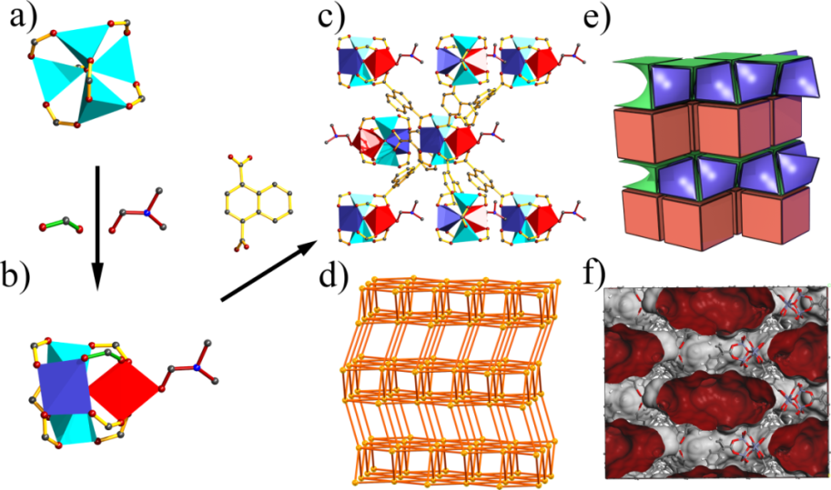**Fig. 1** a)The famous Zn4OH(CO2)6 SBU, b) Zn4(OH)(CO2)7(DMF) in **1**, c) the 7-connected SBU, d) the ***sev*** topology, e) three kinds of tiling in the topology and f) the pore surface of **1** simulated by Material Studio.

**Table 2** Performances of some MOFs as photocatalysts for the degradation of organic pollutants in aqueous media.

|  |  |  |  |  |  |
| --- | --- | --- | --- | --- | --- |
| MOF | Irrigation | Pollutants | Time(min) | Degradation  efficiency (%) | Ref. |
| Ti2(dobdc)3 | Vis | Rh B(H2O2) | 80 | 100 | 16a |
| Cu2(hfipbb)2(4,4’-bpy)(H2O) | Vis | Rh B | 360 | 70 | 16b |
| (Me4N)6[Cu12(OMe)6(pz)6(btc)6] | UV | Rh B | 320 | 61 | 16c |
| (Me4N)6[Cu12(OH)6(pz)6(btc)6] | UV | Rh B | 320 | 51 | 16c |
| Cu4(dcpcpb)2(μ3-OH)2(CH3OH)2 | UV | Rh B | 90 | 19 | 16d |
| Co2(dcpcpb)( μ3-OH)(H2O)2 | UV | Rh B | 90 | 79 | 16d |
| Cu6(μ3-O)(μ3-OH)(pz)6(btc) | UV | Rh B | 105 | 79 | 16e |
| Cu(ptz)(II) | Vis | Rh B(H2O2) | 35 | 70 | 16f |
| [Co2(4,4’-bpy)](4,4’-obb)2 | UV | Rh B | 100 | 62 | 16g |
| [Ni2(4,4’-bpy](4,4’-obb)2 | UV | Rh B | 100 | 47 | 16g |
| [Zn2(4,4’-bpy)](4,4’-obb)2 | UV | Rh B | 100 | 43 | 16g |
| MIL-53(Fe) | Vis | Rh B | 50 | 62.1 | 16h |
| [Co2(1,4-bdc)(ncp)2] | Vis | Rh B | 300 | 67.52 | 16i |
| UO2(1,4-ndc)((CH3)2SO)) | UV-Vis | RhB | 70 | 100 | 16j |
| [Cd(4,4’-bpy)(H2O)2(S2O3)] | UV | MV | 90 | 99 | 16k |
| [Cd(4,4’-bpy)(H2O)2(S2O3)] | sunlight | MV | 90 | 70 | 16k |
| [Co2(1,4-bdc)(ncp)2] | Vis | MV | 300 | 33.29 | 16l |
| **1** | UV-vis | RhB | 45 | 56.9 | **This work** |
| **1** | UV-vis | MV | 45 | 78.3 | **This work** |

Hence, to explore further the main active species and the photocatalytic mechanism for degradation of MV, the trapping experiments were conducted by introducing 10 mg benzoquinone (BQ, as a quencher of O2·–) or 0.2 mL tertiary butyl alcohol (TBA, as a quencher of ·OH) or 10 mg ammonium oxalate (AO, a quencher of holes, h+) in the reaction medium. It was observed that the photocatalytic degradation efficiency of **1** to MV declined to 29.9 % with BQ, 55.6% with TBA and 67.5% with AO, respectively (Fig. 3). Thus, these experiments indicates that these three active species *viz.* O2·–, ·OH and h+ are responsible for the photocatalytic degradation of MV. The photocatalytic mechanism may be described as follow: under UV light, electrons (e–) gets excited from valence band (VB) to conduction band (CB) to rise to the same numbers of holes (h+) in VB. Then light-generated electrons (e–) may move from the interior towards the inner pore surface as well as to the surface of **1**, and the superoxide radicals are generated when e–combines with O2 present in the water. Thereafter, the hydroxyl radicals are produced by the reaction of O2·– with H2O. Due to the extremely strong ability of ·OH to capture electrons, dyes get mineralized into CO2, H2O and other small molecules (Scheme S3).

To check the surface area of **1**, its N2 adsorption experiments had been conducted at 77 K, which exhibited type I isotherm (Fig. 4a and Fig. S5). This indicates that **1** behaves like microporous material with BET surface area of 105 m2/g.15**1** selectively adsorbs N2 at 77 K with an uptake of 91 cm3 g-1 at 1 atm (Fig. 4a). After photocatalysis the PXRD datafor**1** was collected which indicated that the PXRD patterns are nearly identical to the PXRD pattern of as-synthesized **1**whichhence indicated that the basic framework of **1**remained unchanged after photocatalytic experiments (Fig. 4b). The PXRD experiment proves that **1** is potentially a photocatalyst with improved photocatalytic activity for the degradation of aromatic dyes. In addition, **1** could be recovered from the reaction medium by centrifugation and thereafter can be reused for fresh photocatalytic cycle where it displayed no noticeable catalytic efficiency decay even recycling the same material for four times (Fig. S6). The stability of recycled samples had further been confirmed with the aid of FTIR spectroscopy (Fig. S7).

To establish the plausible mechanistic pathway for photo-degradation of aromatic dyes in presence of **1**, the band structure calculations for **1** which is based on DFT method has been performed. The density of states (DOS) and partial DOS (pDOS) patterns for the MOF is shown in Fig. 5. The pDOS plots indicate that the valence band in **1** is having main contribution from aromatic carbon centers and oxygen centers of the carboxylate groups with small contribution from Zn(II) center. In addition, the conduction band in the range of -0.35 to 0.87 eV have been derived from carbon centers with additional contribution coming from oxygen centers. Hence on the basis of DOS and pDOS plots it can be inferred that electronic transitions in the MOF is taking place from the aromatic center to another aromatic region (ligand-to-ligand) with additional contribution from carboxylate oxygen centers. Hence, during photo-excitation, charge transfer operates from HOMO towards LUMO to generate hole. Therefore, the HOMO strongly needs one electron to return to its stable state. Thus, one electron is captured from water molecule which in turn gets converted to ∙OH active

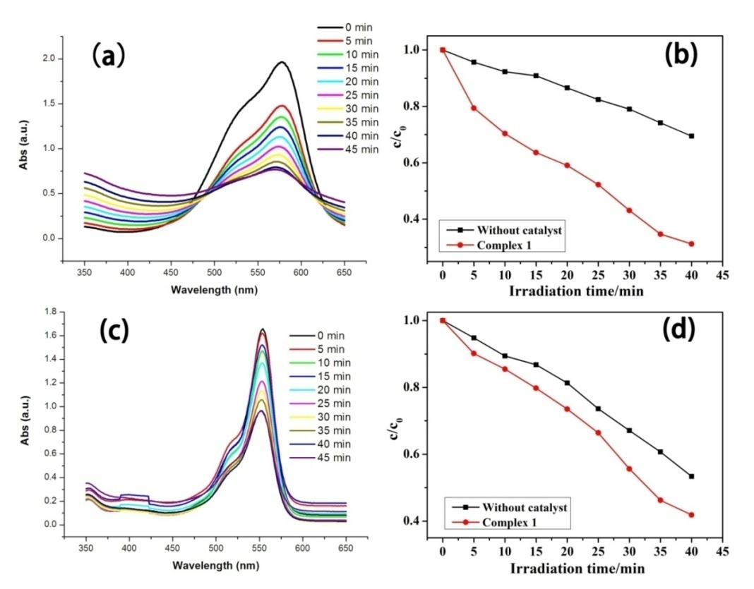

**Fig. 2** (a) and (c) The UV-vis absorption spectra of the MV/Rh B solution during the decomposition reaction; (b) and (d) photocatalytic degradation of MV/Rh B solution under UV with the use of compound **1**; the black curve is the control experiment without any catalyst.

species. The generated ∙OH radicals could decompose the dye effectively to complete the photocatalytic process. The mechanistic scheme suggested to operate during the photocatalytic decomposition of MV in the presence of MOF **1** can be summarised as follows.21-22

**1 1* i.e. 1(h+ + e¯) (1)**

**1(h+ + e¯) + H2O 1(e¯) + HO· + H+ (2)**

**HO· + MV oxidation products CO2 + H2O (3)**

**1 (e¯) + O2 1(O2·¯) (4)**

**O2·¯/HO2· + S oxidation products (5)**

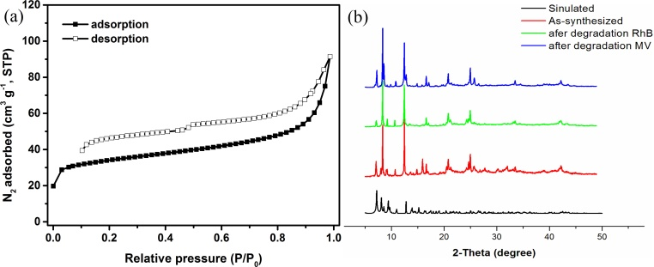

**Fig.3** Trapping experiment of active species during thephotocatalytic reaction of **1**.

**Fig. 4 (a)** N2 adsorption and desorption isotherms of **1**; **(b)** PXRD patterns for **1** simulated (black), single-phase polycrystalline sample (red) and recycled sample (green and blue) of **1**.

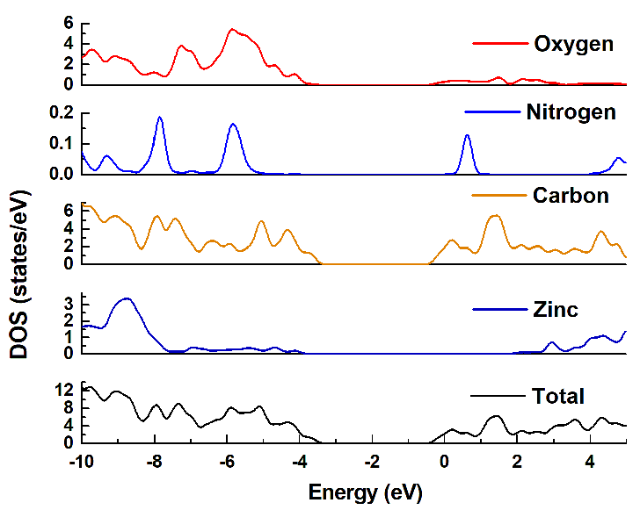**Fig. 5** The DOS and partial DOS plot for 1.

Conclusion

An uncommon Zn(II)-based 3D metal–organic framework has been successfully synthesized under mild solvothermal conditions, which is constructed by polynuclear zinc clusters and 1,4-naphthalenedicarboxylic acid linkers. **1** exhibited an uncommon ***sev*** topology which comprises of famous Zn4O unit with the channel of 9.23 Å diameters. The unique framework of **1** showed promising photocatalytic properties to photo-decompose organic dyes MV and Rh B under UV irradiation. This investigation will provide impetus to develop strategy for synthesizing similar d10-based MOFs with uncommon topologies and optimized pore sizes which can be used as new photocatalysts.

Acknowledgements

This research was partially funded by the Public Research and Capacity Building Projects of Department of Guangdong Province grant number (2017A010103022), Natural Science Foundation of Guangdong Province (2017A030313079), Featured Innovation Project of Guangdong Province (2017KTSCX083, 2018KTSCX083) and Special Funds for Scientific Technological Innovation of Undergraduates in Guangdong Province (pdjha0218, pdjha0219, pdjha0226, pdjh2019b0215, pdjh2019b0222, pdjh2019b0219, pdjh2019b0221).

References

1. (a)C. Wang, J. Li, X. Lv, Y. Zhang and G. Guo, *Energy Environ. Sci.*, 2014, **7**, 2831–2867; (b) X. Feng, Y.Q. Feng, N. Guo, Y.L. Sun, T. Zhang, L.F. Ma and L.Y. Wang, *Inorg. Chem.,* 2017, **56**, 1713-1721.
2. (a) T. Toyao, M. Saito, M. Horiuchi, K. Mochizuki, M. Iwata, H. Higashimura and M. Matsuoka,*Catal. Sci. Technol.*, 2013, **3**, 2092–2097; (b) X. G. Yang, L. F. Ma and D. P. Yan, *Chem. Sci.*, 2019, **10**, 4567–4572; (c) Y. J. Cheng, R. Wang, S. Wang, X. J. Xi, L. F. Ma and S. Q. Zang, *Chem. Commun.*, 2018, **54**, 13563-13566; (d) X. L. Wang, J. Luan, H. Y. Lin, C. Xu, G. C. Liu, J. W. Zhang and A. X. Tian, *CrystEngComm.*, 2013, **15**, 9995–10006.
3. (a) M. Elton, P. Camille, *J. Mater. Chem. A*, 2015, **3**, 22484–22506; (b) X. Feng, X.L. Ling, L. Liu and L.Y. Wang, *Dalton Trans.,* 2013,**42**, 10292-10303; (c) X. Feng, L.F. Ma, L. L, S.Y. Xie, L.Y. Wang, *Cryst. Growth Des.,* 2013, **13**, 4469-4479; (d) X. Feng, N. Guo, H.P. Chen, H.L. Wang, L.Y. Yue, X. Chen, S.W. Ng, X.F. Liu, L.F. Ma, L.Y. Wang, *Dalton Trans.,*2017, **46**,14192-14200.
4. (a) M. Alvaro, E. Carbonell, X. Ferrer, L. Xamena and H. Garcia, *Chem.- Eur. J.*, 2007, **13**, 5106–5112; (b) Q. Q. Xiao, D. Liu, Y. L. Wei and G. H. Cui, *Polyhedron*, 2019, **158**, 342–351; (c)Y. Zhao, X. G. Yang, X. M. Lu, C. D. Yang, N. N. Fan, Z. T. Yang, L. Y. Wang and L. F.Ma, *Inorg. Chem.*,2019,**58**, 6215-6221.
5. (a) M. Masoomi, M. Bgheri and A. Morsali, *CrystEngComm*, 2017, **19**, 5749–5754; (b) Y. Zhao, L.Wang, N. N. Fan, M. L. Han, G. P. Yang and L. F. Ma, *Cryst. Growth Des.*, 2018, **18**, 7114-7121; (c) H. R. Fu, N. Wang, J. H. Qin, M. L. Han, L. F. Ma and F. Wang, *Chem. Commun.*, 2018, **54**, 11645–11648; (d) Y. Zhao, D. S. Deng, L. F. Ma, B. M. Ji and L. Y. Wang, *Chem. Commun.*, 2013, **49**, 10299–10301; (e) X. Feng, C. Xu, Z. Wang, S. Tang, W. Fu, B. Ji, L.Y. Wang, *Inorg. Chem.,* 2015,**54**, 2088- 2090.
6. X. Yan, X.Qiu, Z.Yan, H. Li, Y.Gong and J.Lin, *J. Solid State Chem.*, 2016,**237**, 313–322.
7. (a) L. Wen, L. Zhou, B. Zhang, X. Meng, H. Qua and D. Li, *J. Mater. Chem.*, 2012, **22**, 22603–22609; (b) L. F. Ma, M. L. Han, J. H. Qin, L. Y. Wang and M. Du, *Inorg. Chem.*, 2012, **51**, 9431–9442.
8. K. Wang, Z. Lin, S. Huang, J. Sun and Z. Zhang, *Eur. J. Inorg. Chem.*, 2016, **21**, 3411-3416.
9. (a) D. Vodak, M. Braun, J. Kim, M. Eddaoudi and O. M. Yaghi, *Chem. Commun.*, 2001, **0**, 2534–2535; (b) J. Yang, Q. Yue, G. Li, J. Cao, G. Li and J. Chen, *Inorg. Chem.*, 2006, **45**, 2857–2865.
10. (a) Y. M. Fang, X. Ye. L. Xia, W.W. Don, J. Zhao and D. S. Li, *J. Solid. State Chem.*, 2018, **266**, 181; (b) H. L. Li, M. Eddaoudi, M. O'Keeffe and O. M. Yaghi, *Nature*, 1999, **402**, 276; (c) B. F. Meng, Y. Q. Liu, Y. B. Xing, X. Y. Wang and W. Li, *Inorg. Chem. Commum*, 2016, **73**, 142; (d) J. J. Wei, Q. Y. Liu, Y. L. Wang, N. Zhang and W. F. Wang, *Inorg. Chem. Commun*, 2012, **15**, 61; (e) J. J. Deng, B. Q. Song, J. Liang, Y. Q. Jiao, X. S. Wu, L. Zhao, K. Z. Shao and Z. M. Su, *Inorg. Chem. Coomum.*, 2015, **60**, 82; (f) K. H. He, W. C. Song, Y. W. Li, Y. Q. Chen and X. H. Bu, *Cryst. Growth Des.*, 2012, **12**, 1064; (g) K. Wang, Z. Lin, S. Huang, J. Sun and Q. Zhang, *Eur. J. Inorg. Chem.* 2016, 3411; (h) M. Dai, X. R. Su, X. Wang, B. Wu, Z. G. Ren, X. Zhou and J. P. Lang, *Cryst. Growth Des.*, 2014, **14**, 240; (i) Z. F. Wu, B. Tan, C. F. Du, M. L. Feng, Z. L. Xie and Y. Y. Huang, *CrystEngComm*.,2015, **17**, 4288; (j) D. S. Li, J. Zhao, Y. P. Wu, B. Liu, L. Bai, K. Zou and M. Du, *Inorg. Chem.*, 2013, **52**, 8091; (k) H. Y. Cao, Q. Y. Liu, Y. L. Wang, L. L. Chen and L. H. Xiong, *Inorg. Chem. Commum.*, 2013, **34**, 12; (l) J. F. Zhang, L. P. Gong, J. Y. Feng, J. J. Wu and C. Zhang, *New J. Chem.*, 2017, **41**, 8107.
11. J.-C. Jin, J. Wu, W.-C. Liu, A.-Q. Ma, J.-Q. Liu, A. Singh and A. Kumar, *New J. Chem.*, 2018, **42**, 2767-2775.
12. A. Ma, F. Ke, J. Jiang, Q. Yuan, Z. Luo, J. Liu and A. Kumar, *CrystEngComm*, 2017, **19**, 2172–2177.
13. H. Zhang, J. Yang, W. Kan, Y. Liu and J. Ma, *Cryst. Growth Des.*, 2016, **16**, 265−276.
14. (a) X. Wang, C. Gong, J. Zhang, L. Hou, J. Luan and G. Liu, *CrystEngComm.,* 2014, **16**, 7745−7752; (b), M. Dai, X. R. Su, X. Wang, B. Wu, Z. G. Ren, X. Zhou, and J. P. Lang, *Cryst. Growth Des*., 2014, **14**, 240−248; (c) P. Li, Y. He, J. Guang, L. Weng, J. Zhao, S. Xiang and B. Chen, *J. Am. Chem. Soc.*,2014, **136**, 547–549; (d) D. Li, C. Ni, M. Chen, W. Dai, W. Zhang, W. Yan, H. Qi, Z. Ren and J. Lang, *CrystEngComm*, 2014, **16**, 2158–2167.
15. A. K. Paul, G. Madras and S. Natarajan, *Phys. Chem. Chem. Phys.*, 2009, **11**, 11285–11296.
16. (a) J. Gao, J. Miao, P.-Z. Li, Y. Zhao and B. Liu, *Chem. Commun.*, 2014, **50**, 3786; (b) Y.-P. Wu, D.-S. Li, Y.-P. Duan, L. Bai and J. Zhao, *Inorg. Chem. Commun.*, 2013, **36**, 137; (c) X.-P. Zheng, Y. Lu, H. Zhang, Z.-M. Zhang and E.-B. Wang, *Inorg. Chem. Commun.*, 2013, **33**, 29; (d) P. Du, Y. Yang, Y.-Y. Liu, Y.-C. He, H.-M. Zhang and J.-F. Ma, *Polyhedron*, 2014, **70**, 180; (e) H. Zhang, Y. Lu, Z.-M. Zhang and E.-B. Wang, *Inorg. Chem. Commun.*, 2012, **17**, 9; (f) T. Wen, D.-X. Zhang and J. Zhang, *Inorg. Chem.*, 2012, **52**, 12; (g) P. Mahata, G. Madras and S. Natarajan, *J. Phys. Chem. B*, 2006, **110**, 13759; (h) L. Ai, C. Zhang, L. Li and J. Jiang, *Appl. Catal., B*, 2014, **191**, 148–149,; (i) H.-Y. Sun, C.-B. Liu, Y. Cong, M.-H. Yu, H.-Y. Bai and G.-B. Che, *Inorg. Chem. Commun.*, 2013, **35**, 130; (j) Y. Xia, K.-X. Wang and J.-S. Chen, *Inorg. Chem. Commun.*, 2010, **13**, 1542; (k) A. K. Paul, G. Madras and S. Natarajan, *Phys. Chem. Chem. Phys.*, 2009, **11**, 11285; (l) H.-Y. Sun, C.-B. Liu, Y. Cong, M.-H. Yu, H.-Y. Bai and G.-B. Che, *Inorg. Chem. Commun.*, 2013, **35**, 130.
17. (a) M. Alvaro, E. Carbonell, B. Ferrer, F. X. LlabrésiXamena and H. Garcia, *Chem.- Eur. J.,* 2007, **13**, 5106–5112; (b) E. Dias and C. Petit, *J. Mater. Chem. A*, 2015, **3**, 22484–22506.
18. S. Subudhi, D. Rath and K. Parida, *Catal. Sci. Technol.*, 2018, **8**, 679–696.
19. D. Wang, K. Deng, K. Lv, C. Wang, L. Wen and D. Li, *CrystEngComm.*, 2009, **11**, 1442–1450.
20. C. Silva, A. Corma and H. García, *J. Mater. Chem.*, 2010, **20**, 3141–3156.
21. (a) H. Cheng, H. Tang, Y. Shen, N. Xia, W. Yin, W. Zhu, X. Tang, Y. Ma and R. Yuan, *J. Solid State Chem.*, 2015, **232**, 200–206; (b) S.B. Li, L. Zhang, B. R. Lu, E. Y. Yan, T. H. Wang, L. Li, J. X. Wang, Y. Yu and Q. D. Wu, *New J. Chem*., 2018, **42**, 7247-7253; (c) Y. Zhang, J. B. Zhou, X. Chen and Q. Q. Feng, W. Q. Cai, *J. Alloy, Compd*, 2019, **777**, 109-118; (d) M. Z. Hussain, G. S. Pawar, Z. Huang, A. A. Tahir, R. A. Fischer, Y. Q. Zhu and Y. D. Xia, *Carbon*, 2019, **146**, 348-363.
22. J. Wu, B. Li, H. Zhong, S. Qiu, Y. Liang, X. Zhuang, A. Singh, A. Kumar, *J. Mol. Struct.,*2018, **1158**, 264–270.